Stay & Shop Reservation System
Final Project Documentation
CSI 3471 — Software Engineering I
Team: Drop Table Teams
Members: Jace Yarborough, Erick Martinez, Jonathan Deiss, Zain Altaf, Aaron, James Bagwell

Table of Contents

1. Introduction 4
2. Project Overview 4
2.1 Product Perspective 4
2.2 Assumptions and Dependencies 4
3. Requirements 4
3.1 Functional Requirements 4
3.2 Non-functional Requirements 5
3.3 Requirements Clarifications 5
4. Use Case Model 6
4.1 Use Case Diagram 6
4.2 Fully-Dressed Use Cases 8
4.3 Brief Use Cases 12
5. Domain Model (Analysis) 14
6. System Sequence Diagrams (SSD) 15
6.1 SSD — Make Reservation 15
6.2 SSD — Cancel Reservation 16
6.3 SSD — Search Available Room 16
7. Operation Contracts 17
8. Sequence Diagrams (Design) 19
8.1 Design Sequence — Make Reservation 19
8.2 Design Sequence — Cancel Reservation 20
8.3 Design Sequence — Search Available Room 20
9. Design Class Diagram (DCD) 21
10. Implementation Overview 22
10.1 Architecture 22
10.2 Key Design Decisions 22
11. Testing 23
11.1 JUnit Testing Summary 23
11.2 Test Cases Table 23
12. Team Contribution 28
13. Setup / Installation Guide 28
Prerequisites 28
Local Setup 28
Production Deployment (Docker on Hetzner + Traefik) 29
14. User Manual 29
14.1 Guest Workflow 29
14.2 Hotel Clerk Workflow 29
14.3 Admin Workflow 30
14.4 Demo Videos 30

1. Introduction
This document describes the design, implementation, and testing of the Stay & Shop Reservation System, a Java-based web application that automates reservations, guest management, billing, and an in-hotel retail experience for a combined hotel and store. The system was developed as the group project for CSI 3471 (Software Engineering I) at Baylor University.
The intended users are three classes of actors: hotel guests who reserve rooms and shop in the on-premises store, hotel clerks who manage rooms and process reservations, check-ins, check-outs, and billing, and admins who provision clerk accounts. The system addresses the operational problem of running both a hotel and a retail store on the same premises with a single guest identity, a unified billing surface, and consistent room availability.

2. Project Overview

2.1 Product Perspective
The Stay & Shop Reservation System is a self-contained 3-tier application: a React/Vite single-page frontend, a Spring Boot REST API backend, and a SQLite database accessed through jOOQ. It is deployed as two Docker containers behind a Traefik reverse proxy on a Hetzner host, with Let's Encrypt-issued HTTPS. The system is the system-of-record for guest accounts, rooms, reservations, the product catalog, carts, orders, and bills; it does not currently integrate with external payment processors or property management systems, but the controller and service layers are designed so such integrations can be added behind the existing service interfaces.

2.2 Assumptions and Dependencies
- Java 17+ and Maven are available for the backend build.
- Bun is used for frontend dependency management and local development.
- SQLite is the persistence backend; jOOQ classes are generated from schema.sql.
- Docker and Docker Compose are used for production deployment, with an external app-network shared with Traefik.
- Authentication is session-token based (in-memory ConcurrentHashMap), suitable for the project scope but assumed to be replaced with a stateless JWT or session store for any production scale-out.
- Credit card information is collected and stored in-database for the academic scope; a real deployment would tokenize via a PCI-compliant payment processor.

3. Requirements

3.1 Functional Requirements
Guest:
- Register a guest account with username, password, name, address, email, and payment info.
- Log in and log out using username and password.
- Search for rooms available between a check-in and check-out date.
- Make a reservation for a chosen room and rate type (standard, promotion, group, non-refundable).
- Cancel an own reservation prior to check-in, with the cancellation penalty applied per policy.
- Modify an own reservation when within the modification window.
- Browse the in-hotel store product catalog.
- Add items to a shopping cart and check out.
- View a combined bill for the stay and store purchases.
- Leave or view reviews for the hotel.
Hotel Clerk:
- Log in and modify own profile and password.
- Add and modify rooms (number, floor/theme, type, bed type, smoking status, quality level, daily rate).
- View status of all rooms (available, reserved, occupied).
- Make a reservation on behalf of a guest.
- Modify or cancel any reservation prior to check-in, with policy enforced.
- Process check-in (assign room, mark occupied, record timestamp).
- Process check-out (release room, generate final bill).
- Generate a combined bill for any guest.
Admin:
- Log in using username and password.
- Create a hotel clerk account with username and a default password.
- Reset a user account password.

3.2 Non-functional Requirements
- Persistence: all guest, room, reservation, product, cart, order, and bill state survives container restarts via the booking-data Docker volume.
- Security: passwords are stored as BCrypt hashes; authentication tokens are required for all non-public endpoints; role-based authorization (GUEST / CLERK / ADMIN) is enforced at the controller layer.
- Availability: real-time room availability — search results reflect current reservations and check-in state immediately.
- Atomicity: reservations and store checkouts are atomic (all-or-nothing) to prevent inconsistent state.
- Auditability: cancellations, login attempts, and clerk-initiated reservations are logged.
- Portability: the system is built as Java SE / Spring Boot and runs on any Docker-capable host. Development setup runs identically on Linux, macOS, and WSL.
- Code quality: 75 JUnit tests across 12 test classes provide regression coverage for the controller, service, and utility layers.

3.3 Requirements Clarifications
Cancellation policy: per the project problem statement, cancellation is free if made within 2 days of the reservation date; after that, the guest is charged 80% of one night at the reservation rate. The system implements both cases and records the fee on the reservation record.
Store purchases for non-checked-in guests: the system requires a guest to be checked in to add items to a cart. This was chosen as the simplest, safest interpretation of the prompt's open question ("what happens if a guest who did the check out and is no longer part of the hotel tries to buy something").
Use of Web UI vs. Swing: per the bonus rule, the team implemented a web frontend (React/Vite) instead of Swing. All software-engineering artifacts (use cases, sequence diagrams, design class diagrams, contracts, tests) remain anchored on the Java backend.

4. Use Case Model

4.1 Use Case Diagram
The system has four actors — Admin, Hotel Clerk, Guest, and Previous/Potential Guest — interacting with seventeen use cases grouped under the Hotel Management System boundary. Admin owns clerk-account provisioning and login; Clerks own room inventory, check-in/out, billing, and clerk-initiated reservations; Guests own self-service registration, search, reservation lifecycle, in-store purchasing, and help-desk requests; Previous and potential guests interact with the review subsystem.
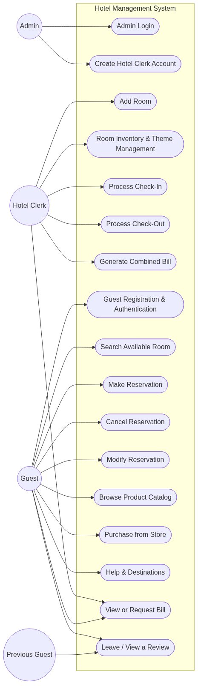
Figure 1: Use Case Diagram

4.2 Fully-Dressed Use Cases
One fully-dressed use case is provided per team member. Remaining use cases appear in brief form in section 4.3.
4.2.1 Admin Login — Jace Yarborough
Use Case Name | Admin Login
Author | Jace Yarborough
Actor | Admin
Preconditions | 1. System operational  2. User has a valid admin account with username and password
Postconditions | 1. Admin is successfully logged in  2. Admin is redirected to admin dashboard/panel
Main Success Scenario | 1. Admin navigates to login page  2. Admin enters username  3. Admin enters password  4. Admin submits credentials  5. System validates input  6. System verifies credentials  7. System displays success message  8. Admin is brought to admin dashboard
Extensions | 4a. Invalid username format: System detects invalid format, displays "Invalid username or password," prompts re-entry.  6a. Invalid credentials: System increments failed-attempt counter, displays generic error, returns to step 2.  6b. Account locked: System displays "Account locked. Contact system administrator." Use case ends.  6c. Password expired: System prompts admin to reset password and redirects to password reset use case.
Special Requirements | Passwords must be hashed in the database.  All login attempts must be logged.

4.2.2 Make Reservation — Erick Martinez
Use Case Name | Make Reservation
Author | Erick Martinez
Actor | Hotel Guest
Preconditions | 1. The hotel system is functional and online  2. The user is logged in to the system  3. Room and reservation data exists in the database  4. The user has searched for available rooms
Postconditions | 1. A new reservation is created in the system  2. The selected room is marked as reserved for the specified dates  3. Guest information is recorded (name, address, credit card number, expiration date)  4. Confirmation is displayed to the user
Main Success Scenario | 1. The user selects a room from the list of available rooms  2. The user enters the check-in and check-out dates  3. The user selects the rate type (standard, promotion, group, or non-refundable)  4. The user enters or confirms their personal information  5. The user enters payment information  6. The system validates all input data  7. The system verifies room availability for the selected dates  8. The system calculates total cost based on quality level and rate type  9. The system creates the reservation and stores it in the database  10. The system displays reservation confirmation with details
Extensions | 3a. Corporate guest selected: User selects their corporation; system records it for billing purposes.  6a. Invalid input data: System displays errors; user corrects input and continues from step 6.  7a. Room no longer available: System notifies user, redirects to search. Use case ends.
Special Requirements | Credit card information must be securely stored.  Reservation must be atomic (all-or-nothing).

4.2.3 Clerk Makes Reservation for Guest — Jonathan Deiss
Use Case Name | Clerk Makes Reservation for Guest
Author | Jonathan Deiss
Actor | Hotel Clerk
Preconditions | 1. Hotel clerk is logged into the system  2. Room and reservation data exists in the database  3. The guest has an existing account or the clerk can look one up
Postconditions | 1. A new reservation is created and associated with the guest  2. The selected room is marked as reserved for the specified dates  3. Guest information is recorded and linked to the reservation
Main Success Scenario | 1. Clerk selects "Make Reservation" from the clerk dashboard  2. Clerk searches for the guest by name or email  3. System displays matching guest records  4. Clerk selects the guest  5. Clerk enters check-in date, check-out date, and desired room type  6. System displays available rooms matching criteria  7. Clerk selects a room  8. Clerk selects a rate type  9. System calculates total cost  10. System creates the reservation and associates it with the guest  11. System displays the reservation confirmation
Extensions | 3a. Guest not found: Clerk creates a new guest record and continues from step 5.  6a. No rooms available: System notifies clerk; clerk adjusts dates or room type and returns to step 5.  8a. Corporate guest: Clerk selects guest's corporation; system marks reservation for deferred corporate billing.
Special Requirements | Reservations created by a clerk must be flagged as clerk-initiated for auditing purposes.  Corporate guest reservations must be marked for deferred billing.

4.2.4 Cancel Reservation — Zain Altaf
Use Case Name | Cancel Reservation
Author | Zain Altaf
Actor | Hotel Guest
Preconditions | 1. The hotel guest is logged into the system  2. The guest has an existing reservation
Postconditions | 1. The reservation is canceled only if cancellation is permitted  2. If cancellation is permitted, any applicable cancellation penalty is recorded  3. If cancellation is not permitted, the reservation remains unchanged
Main Success Scenario | 1. The guest selects the option to view reservations  2. The system displays the guest's reservations  3. The guest selects a reservation to cancel  4. The system checks the time remaining until the reservation's check-in date  5. The system determines that the cancellation request is more than the required time  6. The system displays the applicable cancellation policy and any penalty  7. The guest confirms the cancellation  8. The system cancels the reservation  9. The system displays a cancellation confirmation message
Extensions | 4a. Cancellation not allowed (within 2 days of reservation date): System displays a message that an 80% single-night penalty applies; if guest confirms, fee is recorded and reservation is cancelled. If outside the grace window with no confirmation, the reservation remains unchanged.
Special Requirements | The system must enforce the 2-day grace period and 80% single-night penalty exactly.  Time comparisons must use the hotel's local time zone.  All cancellation attempts must be logged for auditing and billing purposes.

4.2.5 Process Check-Out — Aaron
Use Case Name | Process Check-Out
Author | Aaron
Actor | Hotel Clerk
Preconditions | 1. The hotel system is functional and online  2. The clerk is logged in to the system  3. The guest has been checked in and is currently occupying a room  4. The guest's room and stay details exist in the database
Postconditions | 1. The guest is checked out and the room is released  2. The room status is updated to available  3. The check-out date and time are recorded  4. The final bill is calculated and recorded  5. Any outstanding balance or payment confirmation is documented
Main Success Scenario | 1. Clerk searches for the guest by name, room number, or reservation ID  2. System displays the guest's current stay and room assignment  3. Clerk confirms guest's identity and intent to check out  4. System calculates the final bill (room charges, store purchases, incidentals)  5. System displays the itemized bill to the clerk and guest  6. Guest pays any outstanding balance or confirms prior payment  7. Clerk confirms check-out in the system  8. System updates the room status to available  9. System records the check-out timestamp  10. System displays a check-out confirmation and receipt  11. Clerk provides the receipt or invoice to the guest
Extensions | 1a. Guest or room not found: System displays no matching stay; clerk verifies info; return to step 1.  6a. Payment declined: System displays failure; clerk requests alternative payment or arranges follow-up.  8a. Cannot update room status: System logs failure; clerk retries or escalates; check-out completed manually.
Special Requirements | Check-out must update room availability in real-time for Search Available Room.  Final bill must include all room charges and any store or incidental charges linked to the stay.  Check-out time and payment status must be logged for auditing.

4.2.6 Search Available Room — James Bagwell
Use Case Name | Search Available Room
Author | James Bagwell
Actor | Hotel Guest
Preconditions | 1. The hotel system is functional and online  2. Room and reservation data exists in the database
Postconditions | 1. Available rooms are displayed to the user  2. Data is not modified
Main Success Scenario | 1. The user selects the search option  2. The user enters search criteria (check-in/out dates, number of guests, beds, bed size, etc.)  3. System validates input  4. System searches for rooms that match user criteria  5. System displays the list of available matching rooms
Extensions | 3a. Invalid date range (check-out before check-in or in the past): System displays validation error and prompts user to re-enter dates.  4a. No matching rooms: System displays "No rooms match your criteria" and suggests adjusting the search.
Special Requirements | Search must reflect real-time room availability based on existing reservations.  Read-only operation; no domain state is modified.

4.3 Brief Use Cases
HOTEL CLERK LOGIN (Jonathan Deiss): A hotel clerk logs in with username and password. The system validates the credentials, creates a clerk session, and routes the clerk to the clerk dashboard. Failed attempts return a generic "Invalid username or password" error and are logged.
ADD ROOM (Jace Yarborough): A hotel clerk opens room management, fills out the new-room form (number, floor/theme, room type, bed type and quantity, smoking status, quality level, and max daily rate), and submits. The system validates fields, ensures the room number is unique, persists the room, and confirms success. Validation errors and duplicate-number conflicts return the clerk to the form.
CREATE HOTEL CLERK ACCOUNT (Jace Yarborough): An admin selects "Create Clerk Account," enters a username (and optionally overrides the prefilled default password), and submits. The system validates the username, creates the account, and confirms success. Duplicate usernames return an error with a suggested replacement; backend failures prompt the admin to retry.
VIEW ROOM STATUS (ROOM INVENTORY & THEME MANAGEMENT) (Jonathan Deiss): A clerk opens the room status dashboard. The system retrieves all rooms and displays each with its room number, floor/theme, and live status (available, reserved, or occupied), plus a summary count by status. The clerk can filter by floor or status. If no rooms exist or none match the filter, the system displays an appropriate empty-state message.
BROWSE PRODUCT CATALOG (Jonathan Deiss): A guest browses the in-hotel store catalog. The system retrieves all available products and displays them with name, price, category, and stock. The guest can scroll the catalog freely; no domain state is changed by browsing. (Note: the backing file is shared with Hotel Clerk Login authoring; the catalog browse flow itself is the read-only entry point into Purchase from Store.)
MODIFY RESERVATION (Zain Altaf): A guest views their reservations, selects one that has not yet started, and submits requested changes (e.g., dates or room type). The system enforces the modification policy window, verifies room availability, recalculates cost, displays the updated details, and on guest confirmation persists the changes. Modifications inside the cutoff window are rejected with an explanatory message.
GENERATE COMBINED BILL (Zain Altaf): After a guest checks out, the clerk selects them and the system retrieves the reservation and any in-stay store purchases, calculates room and store totals, applies taxes/fees, and combines them into a single bill. The clerk reviews and confirms; the system finalizes and stores the bill. Corporate guests are flagged for deferred billing with status pending.
PROCESS CHECK-IN (Erick Martinez): A clerk searches for the guest's reservation by name or confirmation number, verifies identity, and assigns an available matching room. The system updates the room to occupied, records the check-in timestamp, and confirms check-in. Extensions cover missing reservations, guest-requested room type changes (with re-rate), and no matching room (offer upgrade or no-penalty cancellation).
PURCHASE FROM STORE (Aaron): A logged-in (typically checked-in) guest adds products to a cart, reviews the order, and checks out. The system validates inventory and payment, decrements stock atomically with the sale, charges the room (if checked in) or processes payment, and confirms the order. Out-of-stock items, payment failures, and missing payment methods for non-checked-in guests are handled with prompts to correct or end the use case.
VIEW OR REQUEST BILL (Aaron): A guest or clerk navigates to billing, selects a stay, and the system retrieves all charges (room, taxes, store purchases, incidentals) and displays an itemized bill. On request the system generates a PDF/printable invoice and either makes it available for download or emails it to the guest. Past stays within retention can have invoices regenerated; in-progress stays may be limited to view-only depending on policy.
HELP DESK (James Bagwell): A guest opens the Help Desk and chooses either virtual technical support (live chat) or a physical service request (technician/housekeeper). The system either connects them to an available staff member or schedules the request and dispatches staff. If no one is available, the system offers a callback or alternate scheduling time. All requests are logged against the guest's room and account.
LEAVE / VIEW A REVIEW (James Bagwell): Any visitor can view existing reviews and the hotel's average rating on the reviews page. Logged-in guests who have previously reserved and checked in can submit a 1–5 star rating with text. The system validates the form, filters profanity, persists the review, and updates the average rating. Visitors can sort by recency or rating and limit how many results are shown.

5. Domain Model (Analysis)
The conceptual domain centers on Person (specialized into Guest, HotelClerk, and Admin), Room, Reservation, Product, Review, HelpRequest, Corporation, and Staff. A Guest has one PaymentInfo, makes many Reservations, writes many Reviews, and submits many HelpRequests. Each Reservation reserves exactly one Room and may be billed to at most one Corporation. An Admin creates many HotelClerks; HotelClerks process check-ins on Reservations. HelpRequests are optionally assigned to Staff.
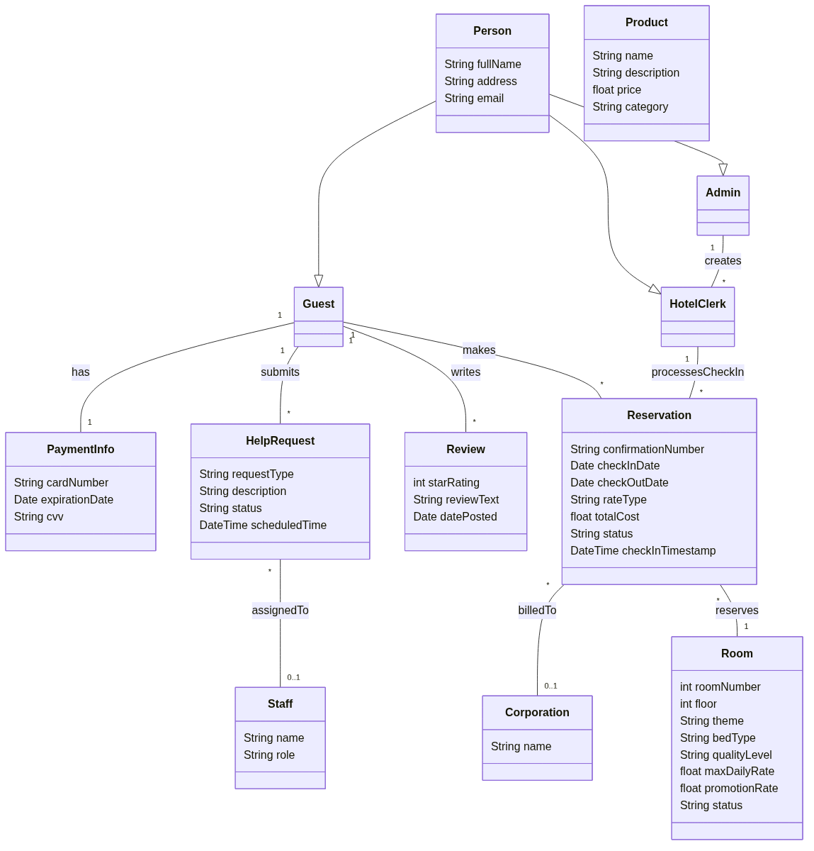
Figure 2: Domain Model

6. System Sequence Diagrams (SSD)
System Sequence Diagrams for the three guest-facing fully-dressed use cases. Each shows the actor and the system as a black box; only system events initiated by the actor are included.

6.1 SSD — Make Reservation
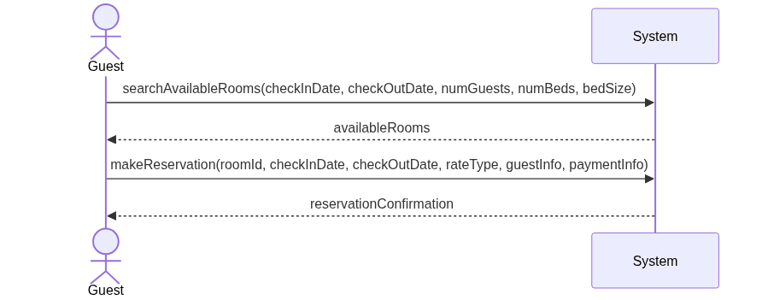
Figure 3: SSD — Make Reservation

6.2 SSD — Cancel Reservation
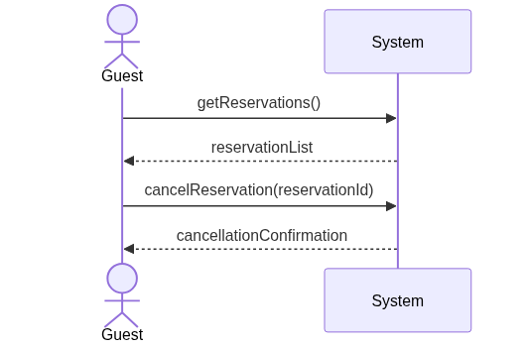
Figure 4: SSD — Cancel Reservation

6.3 SSD — Search Available Room
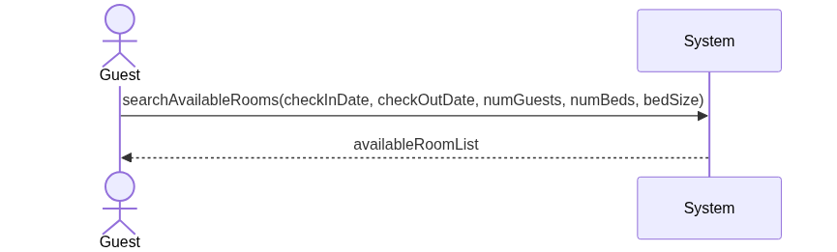
Figure 5: SSD — Search Available Room

7. Operation Contracts
Contract CO1: registerGuest
Author | Erick Martinez
Operation | registerGuest(fullName, address, email, password, paymentInfo)
Cross References | Guest Registration & Authentication
Preconditions | 1. Guest has access to the hotel system portal  2. Guest is not currently logged in  3. The given email is not already registered
Postconditions (Main Success) | 1. A new Guest profile was created in the database  2. Guest password was hashed and stored  3. Payment info was tokenized and stored  4. A new authenticated session was created and associated with the guest
Contract CO2: makeReservation
Author | Erick Martinez
Operation | makeReservation(roomId, checkInDate, checkOutDate, rateType, guestInfo, paymentInfo)
Cross References | Make Reservation
Preconditions | 1. Guest is logged in  2. Selected room is available for the requested dates  3. Room and reservation data exist in the database
Postconditions (Main Success) | 1. A new Reservation was created in the database  2. The selected Room was marked as reserved for the specified dates  3. Guest billing information was recorded  4. Reservation.totalCost was calculated based on quality level and rate type
Contract CO3: cancelReservation
Author | Zain Altaf
Operation | cancelReservation(reservationId)
Cross References | Cancel Reservation
Preconditions | 1. Guest is logged in  2. Reservation exists and is associated with the guest  3. Reservation status is CONFIRMED
Postconditions (Main Success) | 1. Reservation.status was set to CANCELLED  2. Cancellation fee was calculated and recorded (0 if within 2-day grace; otherwise 80% of one night)  3. The cancellation event was logged for auditing
Contract CO4: processCheckOut
Author | Aaron
Operation | processCheckOut(reservationId)
Cross References | Process Check-Out
Preconditions | 1. Hotel clerk is logged in  2. Reservation status is CHECKED_IN  3. Guest's stay details exist in the database
Postconditions (Main Success) | 1. Room.status was changed to AVAILABLE  2. Reservation.status was set to CHECKED_OUT and check-out timestamp recorded  3. Final bill (room + store purchases + incidentals) was generated and stored  4. Payment status was documented and logged
Contract CO5: searchAvailableRooms
Author | James Bagwell
Operation | searchAvailableRooms(checkInDate, checkOutDate, numGuests, numBeds, bedSize)
Cross References | Search Available Room
Preconditions | 1. Hotel system is online  2. Room and reservation data exist
Postconditions (Main Success) | 1. No domain state was modified (read-only)  2. A list of rooms matching the search criteria was retrieved and returned
Contract CO6: clerkMakeReservation
Author | Jonathan Deiss
Operation | clerkMakeReservation(clerkId, guestId, roomId, checkInDate, checkOutDate, rateType)
Cross References | Clerk Makes Reservation for Guest
Preconditions | 1. Hotel clerk is logged in  2. The specified guest account exists  3. The selected room is available for the requested dates
Postconditions (Main Success) | 1. A new Reservation was created and associated with the guest  2. The selected Room was marked as reserved  3. Reservation.totalCost was calculated  4. Reservation was flagged as clerk-initiated and linked to the creating clerk

8. Sequence Diagrams (Design)
Design-level sequence diagrams for the same three fully-dressed use cases. They follow GRASP responsibility assignment: a use-case Controller per use case (e.g., MakeReservationHandler, CancelReservationHandler, SearchRoomHandler), Information Expert assignment to the domain classes that own the data (Room knows its rates; Reservation calculates its own totalCost and final bill), Pure Fabrication catalog classes (RoomCatalog, GuestCatalog, ReservationCatalog, AuditLog) for persistence and lookups, and the Creator pattern applied to Guest creating Reservation per the domain association "Guest 1—* Reservation : makes".

8.1 Design Sequence — Make Reservation
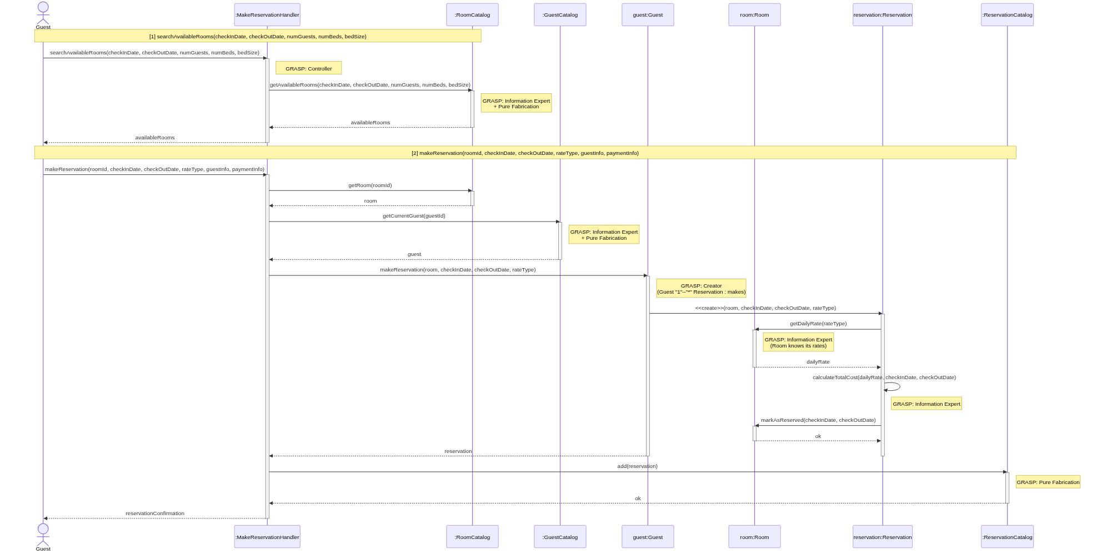
Figure 6: Design Sequence Diagram — Make Reservation

8.2 Design Sequence — Cancel Reservation
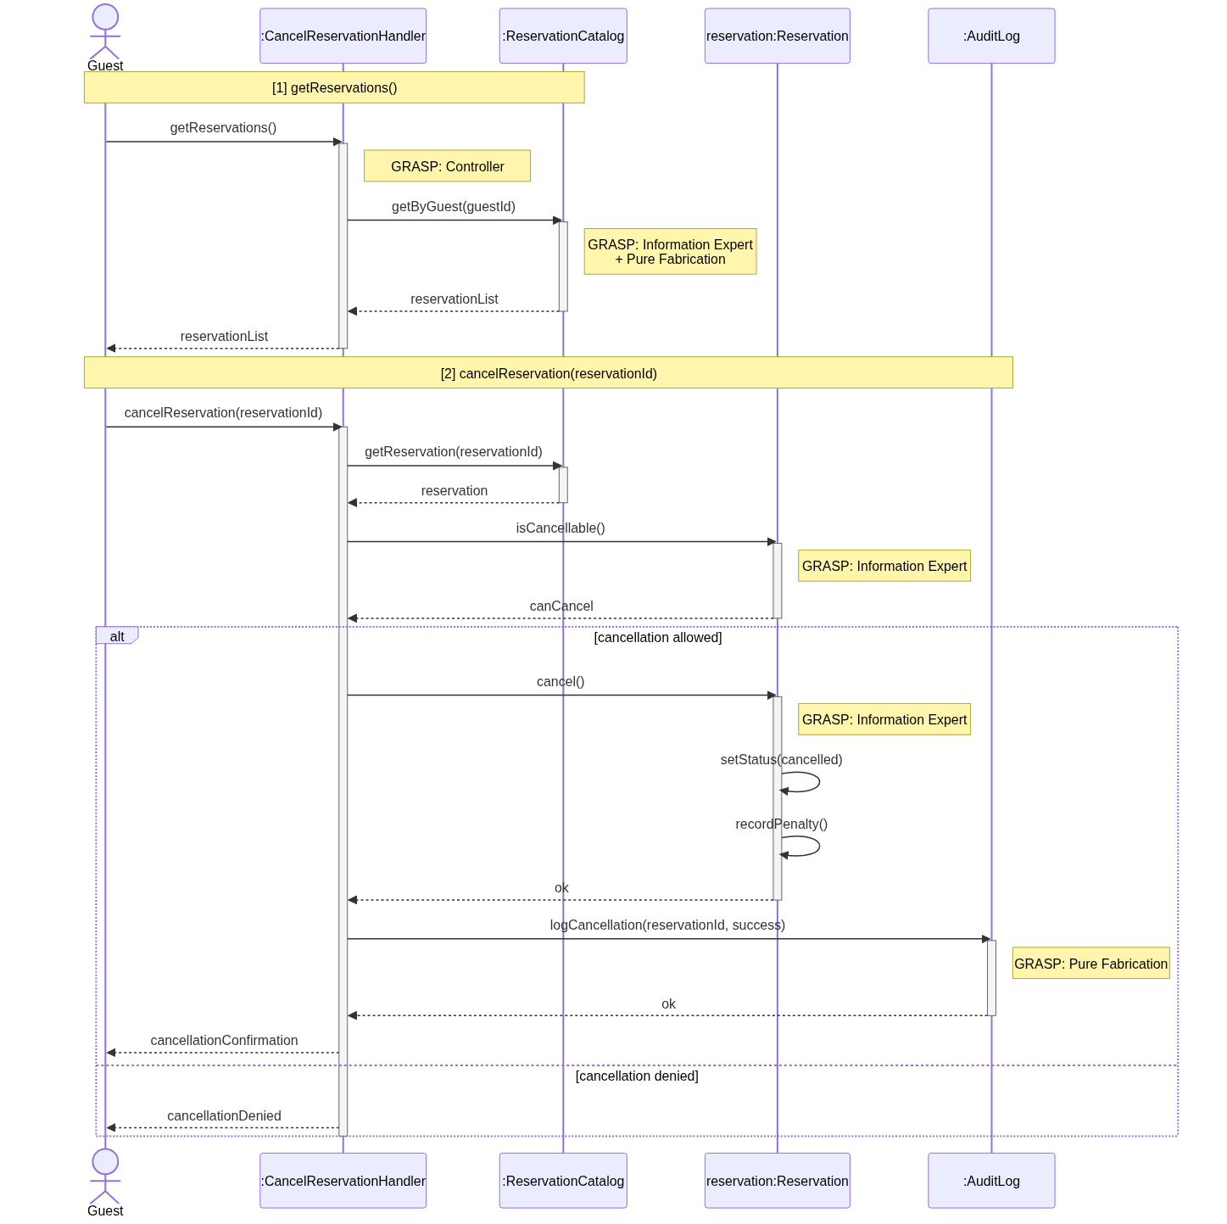
Figure 7: Design Sequence Diagram — Cancel Reservation

8.3 Design Sequence — Search Available Room
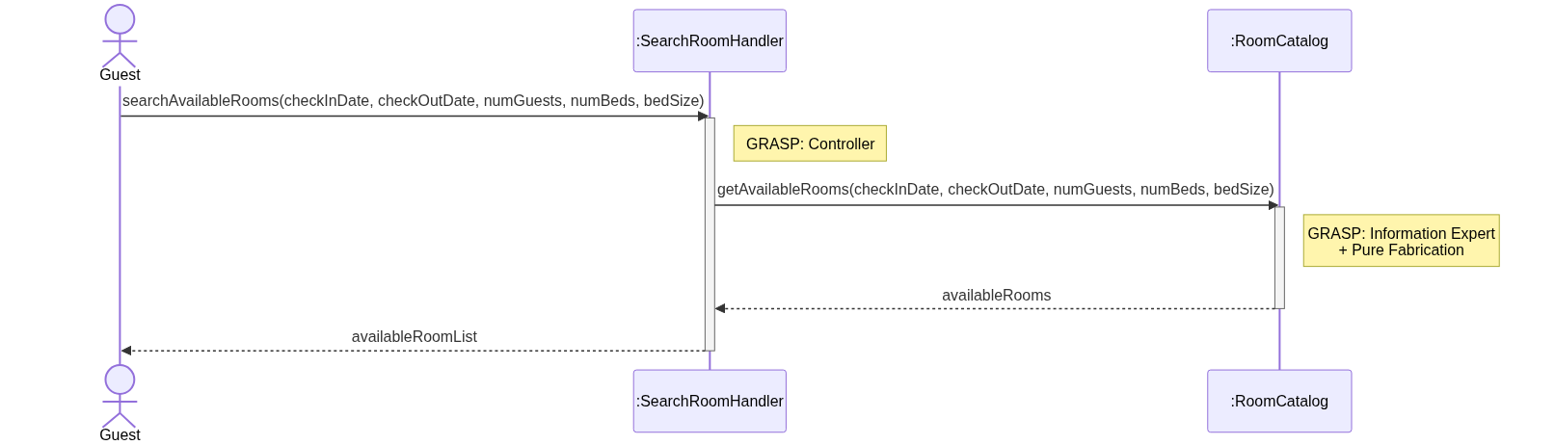
Figure 8: Design Sequence Diagram — Search Available Room

9. Design Class Diagram (DCD)
The implementation realizes the design across four layers, each modeled in the DCD (full diagram in Documentation/IterationTwelve.md):
- DTO layer (records): LoginRequest, RegisterRequest, AuthResponse, UserResponse, RoomDto, ReservationRequest, ReservationDto, ProductDto, CartItemRequest, BillDto.
- Controller layer: AuthController, AdminController, RoomController, ReservationController, StoreController. Each is constructor-injected with its service interface and handles HTTP/JSON, validation, and authorization (token + role check).
- Service layer: IAuthService/AuthService, IAdminService/AdminService, IRoomService/RoomService, IReservationService/ReservationService, IStoreService/StoreService — encapsulate business rules (uniqueness, conflict detection, cancellation policy, atomic checkout).
- Repository layer: UserRepository, RoomRepository, ReservationRepository, ProductRepository, OrderRepository — interfaces with jOOQ-backed implementations (JooqUserRepository, JooqRoomRepository, JooqReservationRepository, JooqProductRepository, JooqOrderRepository) that own DSLContext.
- Three enumerations (UserRole, RoomStatus, ReservationStatus) bound the state machines for authorization, room status, and reservation lifecycle.
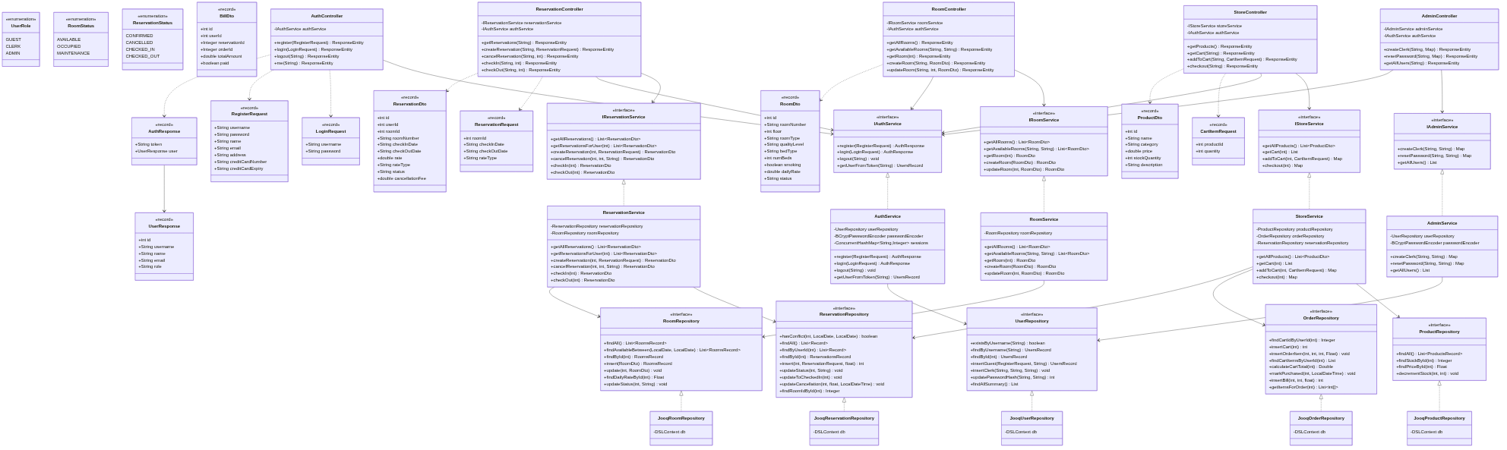
Figure 9: Design Class Diagram
The package/layer view below shows how the implementation packages map onto the four-layer architecture:
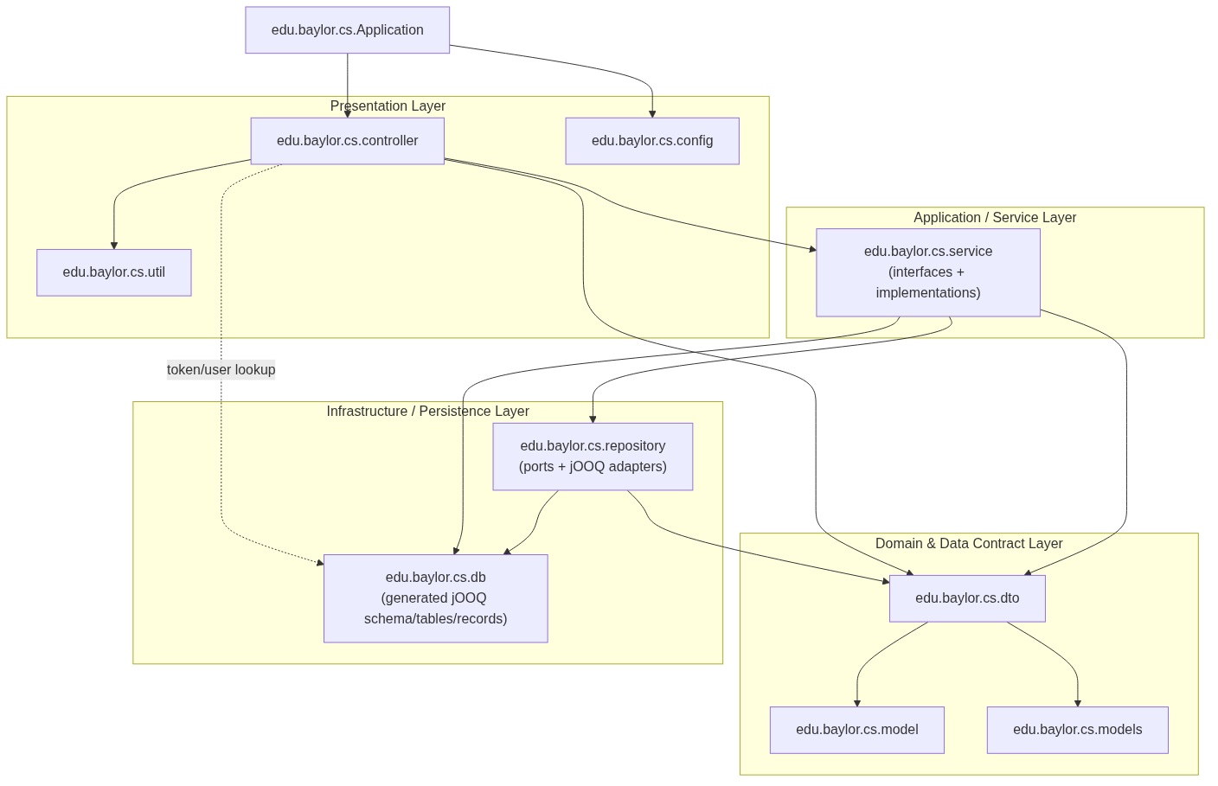
Figure 10: Package / Layer Diagram

10. Implementation Overview

10.1 Architecture
The system is a 3-layered Java application with an additional presentation tier:
- Presentation: React + Vite SPA served by Nginx. Calls /api/* on the same origin; in development, Vite proxies /api → http://localhost:8080.
- Controller (Spring REST): one controller per resource (auth, admin, rooms, reservations, store). Performs authentication via the AuthService (token → user) and role-based authorization, then delegates to the service layer.
- Service: the business layer. Implements all rules — duplicate-username rejection, BCrypt password hashing, reservation conflict detection, cancellation-fee calculation, room-status transitions, atomic cart checkout with stock decrement and bill creation.
- Repository (jOOQ): the persistence layer. Each repository interface has a single Jooq implementation that translates between domain operations and SQL via the generated jOOQ classes. SQLite is the storage engine; the schema is bootstrapped from schema.sql on first startup.
Cross-cutting concerns: TokenExtractor utility for Bearer header parsing; in-memory session map in AuthService; CORS configured per APP_CORS_ALLOWED_ORIGINS env var; HTTPS handled by Traefik in production.

10.2 Key Design Decisions
- Service interfaces (IAuthService, IRoomService, etc.) — controllers depend only on the interface, which keeps controllers testable with mocks (see test summary) and lets us swap implementations (e.g., for an in-memory test double) without touching controllers.
- jOOQ over JPA — the team chose jOOQ for type-safe SQL generated from schema.sql. This puts the schema first and makes complex queries (date-range conflict detection, available-rooms-between) straightforward to read.
- DTOs as records — request/response payloads are immutable Java records, eliminating boilerplate and clearly separating wire types from domain entities.
- Cancellation policy in the service, not the controller — ReservationService.cancelReservation calculates the 0% (within grace) vs. 80%-of-one-night fee. This is unit-tested in ReservationServiceTest and not duplicated anywhere.
- Atomic checkout — StoreService.checkout decrements stock, marks the cart purchased, and creates a Bill in a single transaction; controller-level retries are not needed.
- Frontend bootstrapped from a Stitched AI design — UI/UX scaffolding came from a generated design and was hand-finished, allowing the team to focus engineering effort on the backend domain logic that this course grades on.

11. Testing

11.1 JUnit Testing Summary
The backend is covered by 75 JUnit tests across 12 test classes, organized by layer:
- Controller tests (AdminControllerTest, AuthControllerTest, ReservationControllerTest, RoomControllerTest, StoreControllerTest) — verify HTTP status codes, role-based authorization (GUEST vs. CLERK vs. ADMIN), and request/response wiring. Services are mocked.
- Service tests (AdminServiceTest, AuthServiceTest, RoomServiceTest, ReservationServiceTest, StoreServiceTest) — verify business rules: duplicate-username rejection, password hashing, conflict detection, cancellation-fee calculation (in-grace vs. out-of-grace), room-status transitions, cart/stock atomicity. Repositories are mocked.
- Utility tests (TokenExtractorTest) — verify edge cases for Bearer header parsing.
All 75 tests pass on the current main branch. The full suite runs via mvn test and is the canonical regression check before any merge.
Coverage gap: integration and end-to-end tests that exercise the SQLite database and the React UI together (e.g., via Playwright) are not yet implemented — current tests are pure unit tests with mocks at every layer boundary. This is documented as a future work item.

11.2 Test Cases Table
The following representative test cases summarize the JUnit suite. The full per-test list (with all 75 cases) is in Documentation/Deliverable14.md.
Test Case ID | TC-01
Assigned Tester | Team (mvn test)
Scenario/Condition | Admin creates a new clerk account
Test Inputs | Mock admin user; clerk username "newclerk"; valid auth token
Expected Result | HTTP 200; response contains username "newclerk"
Actual Result | Pass
Test Status | Passed

Test Case ID | TC-02
Assigned Tester | Team (mvn test)
Scenario/Condition | Non-admin guest attempts to create clerk account
Test Inputs | Mock guest user with role GUEST; valid token
Expected Result | HTTP 403 Forbidden
Actual Result | Pass
Test Status | Passed

Test Case ID | TC-03
Assigned Tester | Team (mvn test)
Scenario/Condition | User registers with valid data
Test Inputs | username "alice", password "pass", name "Alice", email "a@b.com", credit card data
Expected Result | HTTP 200; auth token returned
Actual Result | Pass
Test Status | Passed

Test Case ID | TC-04
Assigned Tester | Team (mvn test)
Scenario/Condition | Authenticated guest creates a reservation
Test Inputs | Guest user; roomId 1; checkIn 2025-07-01; checkOut 2025-07-05; rateType STANDARD
Expected Result | HTTP 200; reservation created with id 1
Actual Result | Pass
Test Status | Passed

Test Case ID | TC-05
Assigned Tester | Team (mvn test)
Scenario/Condition | Guest attempts to perform clerk-only check-in
Test Inputs | Mock guest user; reservation id 1
Expected Result | HTTP 403 Forbidden
Actual Result | Pass
Test Status | Passed

Test Case ID | TC-06
Assigned Tester | Team (mvn test)
Scenario/Condition | Cancellation within 2-day grace period
Test Inputs | Reservation created recently; status CONFIRMED
Expected Result | Cancellation fee = 0.0; status set to CANCELLED
Actual Result | Pass
Test Status | Passed

Test Case ID | TC-07
Assigned Tester | Team (mvn test)
Scenario/Condition | Cancellation outside grace period
Test Inputs | Reservation created 10 days ago; 4-night stay at $100/day
Expected Result | Cancellation fee = $80 (80% of one night)
Actual Result | Pass
Test Status | Passed

Test Case ID | TC-08
Assigned Tester | Team (mvn test)
Scenario/Condition | Cannot cancel a checked-in reservation
Test Inputs | Reservation id 1; status CHECKED_IN
Expected Result | IllegalArgumentException thrown
Actual Result | Pass
Test Status | Passed

Test Case ID | TC-09
Assigned Tester | Team (mvn test)
Scenario/Condition | Guest cannot cancel another guest's reservation
Test Inputs | Reservation owner userId 2; canceller userId 99
Expected Result | IllegalArgumentException thrown
Actual Result | Pass
Test Status | Passed

Test Case ID | TC-10
Assigned Tester | Team (mvn test)
Scenario/Condition | Clerk performs check-in
Test Inputs | Mock clerk; reservation id 1
Expected Result | HTTP 200; reservation marked CHECKED_IN; room set OCCUPIED
Actual Result | Pass
Test Status | Passed

Test Case ID | TC-11
Assigned Tester | Team (mvn test)
Scenario/Condition | Clerk performs check-out
Test Inputs | Reservation id 1; status CHECKED_IN; room id 5
Expected Result | Status CHECKED_OUT; room set AVAILABLE
Actual Result | Pass
Test Status | Passed

Test Case ID | TC-12
Assigned Tester | Team (mvn test)
Scenario/Condition | Clerk creates a new room
Test Inputs | Mock clerk; roomNumber "101", floor 1, type STANDARD, quality ECONOMY, bed QUEEN, dailyRate 100.0
Expected Result | HTTP 200; room created with number "101"
Actual Result | Pass
Test Status | Passed

Test Case ID | TC-13
Assigned Tester | Team (mvn test)
Scenario/Condition | Search available rooms by date range
Test Inputs | checkIn 2025-07-01; checkOut 2025-07-05
Expected Result | HTTP 200; only available rooms returned
Actual Result | Pass
Test Status | Passed

Test Case ID | TC-14
Assigned Tester | Team (mvn test)
Scenario/Condition | Add to cart for checked-in guest
Test Inputs | Guest userId 1 (checked in); productId 5; quantity 2; stock 10
Expected Result | HTTP 200; orderId returned
Actual Result | Pass
Test Status | Passed

Test Case ID | TC-15
Assigned Tester | Team (mvn test)
Scenario/Condition | Add to cart blocked when not checked in
Test Inputs | Guest userId 1 (not checked in); productId 5
Expected Result | IllegalArgumentException thrown
Actual Result | Pass
Test Status | Passed

Test Case ID | TC-16
Assigned Tester | Team (mvn test)
Scenario/Condition | Checkout completes and decrements stock
Test Inputs | Guest userId 1; cart with 2 items totalling $15
Expected Result | HTTP 200; bill created; stock decremented
Actual Result | Pass
Test Status | Passed

Test Case ID | TC-17
Assigned Tester | Team (mvn test)
Scenario/Condition | Token extractor handles Bearer prefix
Test Inputs | header: "Bearer xyz"
Expected Result | Returns "xyz"
Actual Result | Pass
Test Status | Passed

12. Team Contribution
Each member owned at least three use cases through analysis, design, and implementation, plus one or more cross-cutting backend or frontend areas. All members contributed to documentation, testing, and the final demo.
Member | Responsibilities | Contribution
Jace Yarborough | Frontend setup; Admin Login, Add Room, Create Hotel Clerk Account use cases; UI integration | ~17%
Erick Martinez | Stitched AI frontend integration; UI/UX design; Guest Registration, Make Reservation, Process Check-In use cases | ~17%
Jonathan Deiss | Database, jOOQ schema, and repository setup; Hotel Clerk Login, View Room Status, Clerk Makes Reservation use cases | ~17%
Zain Altaf | Auth controller; Cancel Reservation, Modify Reservation, Generate Combined Bill use cases | ~17%
Aaron | Search controller; Process Check-Out, Purchase from Store, View or Request Bill use cases | ~17%
James Bagwell | Utility classes; Jira/issue-tracking maintenance; Search Available Room, Help Desk, Review use cases | ~15%

13. Setup / Installation Guide

Prerequisites
- Java 17 or higher
- Maven (for the backend)
- Bun (for the frontend)
- SQLite3 (for the database)

Local Setup
- Clone the repository from GitHub.
- Generate the jOOQ classes from schema.sql by running ./scripts/generate-db.sh once after cloning (and whenever the schema changes).
- In one terminal, start the backend: mvn spring-boot:run. The API will be available at http://localhost:8080.
- In another terminal, install frontend dependencies and start the dev server: cd frontend, bun install, bun run dev. The frontend will be available at http://localhost:5173 and Vite will proxy /api to the backend.

Production Deployment (Docker on Hetzner + Traefik)
- On the host, install Docker and the Compose plugin and create a shared network: docker network create app-network.
- Deploy the Traefik reverse proxy stack on app-network with Let's Encrypt enabled (configuration in Documentation/deployment/README.md).
- Clone the repo on the server, copy .env.example to .env, and set APP_HOST and APP_CORS_ALLOWED_ORIGINS.
- Build and start the application: docker compose up -d --build.
- Verify with docker compose ps and docker compose logs -f backend frontend. The app will be available at https://<APP_HOST>.
Persistence: the booking-data Docker volume is mounted at /app/data and survives container restarts. On first startup, the backend auto-initializes booking.db from schema.sql if the file does not exist.
The deployed instance for this project is at https://hotel.aarondevelop.com/.

14. User Manual

14.1 Guest Workflow
Open the hotel website and click Register. Provide your name, address, email, password, and credit card information. After registration you are logged in automatically and routed to the guest dashboard.
From the dashboard, click Search Rooms. Enter your check-in and check-out dates and any preferences (number of guests, beds, bed size). The system displays only rooms that are free for the entire date range.
Pick a room and click Make Reservation. Choose a rate type (standard, promotion, group, non-refundable), confirm your billing details, and submit. Your reservation appears on My Reservations with a confirmation number.
To cancel, open My Reservations, choose the reservation, and click Cancel. If you are within 2 days of when the reservation was made, there is no fee; otherwise the system shows the 80%-of-one-night fee before you confirm.
Once you are checked in by a clerk, you can browse the in-hotel store from the Store tab. Add items to your cart, review the cart, and check out — purchases are charged to your room and appear on the combined bill.
View your bill any time from My Stay → View Bill. You can request a downloadable PDF invoice from the same page.

14.2 Hotel Clerk Workflow
Log in with your clerk credentials provided by the admin. The clerk dashboard exposes Rooms, Reservations, Check-in / Check-out, and Billing.
Use Add Room to add a new room with number, floor/theme, room type, bed configuration, smoking status, quality level, and daily rate. Use the room status dashboard to see all rooms with live status (available, reserved, occupied) and filter by floor or status.
Use Make Reservation to look up a guest by name or email and book on their behalf — useful for walk-ins or phone reservations. Reservations created this way are flagged as clerk-initiated.
Use Check-In to find a guest's reservation by name or confirmation number, verify identity, assign an available matching room, and mark the room occupied. Use Check-Out to release the room, generate the final bill (room + store + incidentals), and confirm payment.
Use Generate Combined Bill on any checked-out guest to assemble a single bill from their reservation and any store purchases.

14.3 Admin Workflow
Log in with admin credentials. The admin dashboard exposes Create Clerk Account and Reset Password.
To onboard a clerk: open Create Clerk Account, enter the desired username, and confirm the prefilled default password (or override it). Hand the credentials to the new clerk; they should change the password on first login.
To recover an account: open Reset Password, look up the user by username, and submit a new password. The user can log in immediately with the new password.

14.4 Demo Videos
Demonstration videos for the final presentation are in Documentation/videos/ (Family_Water_Park_Resort_Video.mp4 and Hotel_App_Ad_With_Fun_Families.mp4). Each video walks through the three use cases owned by the responsible team member end-to-end against the deployed instance.

